杭州电子科技大学信息工程学院

《JSP程序设计》

作业名称：数据的增删改查JDBC综合运用
学 号： 199050418
姓 名： 刘柏田
专业班级： 190905104
任课老师： 周 梦 熊
时 间： 2019-2020学年第2学期

目 录
1 总 体 设 计 1
1.1内容描述 1
1.2数据库设计 1
1.3项目结构 1
2 关键代码 2
3 运行测试 3

总 体 设 计

1.1内容描述
- 能够通过jsp网页端对数据库进行 增删改查
- 对提交的参数进行检查 若有非法字符 则进行拦截
- 对参数的编码进行处理 整个网站不能有乱码

1.2数据库设计
表名1
字段名称 | 字段类型 | 字段长度 | 是否为空 | 是否关键字 | 字段注释
Id | Int |  | 否 | 是
Username | String |  | 否
Password | String |  | 否
Age | Int |  | 否
gender | Int |  | 否
Birthday | String |  | 否
Phone | String |  | 否

1.3项目结构
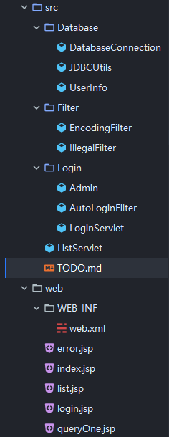

2 关键代码

2.1 IllegalFilter 参数非法字符检测
@Override
public void doFilter(ServletRequest servletRequest, ServletResponse servletResponse, FilterChain filterChain) throws IOException, ServletException {

ArrayList<String> params = new ArrayList<>();
params.add("username");
params.add("password");
params.add("id");
params.add("age");
params.add("gender");
params.add("birthday");
params.add("phone");

for (String str : params) {
String checkString = servletRequest.getParameter(str);
if (checkString != null) {
if (validateString(checkString)){
// 合法
filterChain.doFilter(servletRequest,servletResponse);

} else {

System.out.println(checkString);
servletRequest.getRequestDispatcher("/error.jsp").forward(servletRequest,servletResponse);
}
} else {
filterChain.doFilter(servletRequest,servletResponse);
}
break;

}

}

private boolean validateString(String string) {
return string.indexOf('\'') == -1 && string.indexOf('\"') == -1;
}

2.2 EncodingFilter 全局编码 防止乱码
request.setCharacterEncoding("utf-8");
response.setCharacterEncoding("utf-8");

response.setContentType("text/html;charset=utf-8");

filterChain.doFilter(request,response);
2.3 自动登陆处理的Servlet
String userName = req.getParameter("username");
System.out.println(userName);
String password = req.getParameter("password");
System.out.println(password);

if (defaultUserName.equals(userName) && defaultPassWord.equals(password)) {
Admin admin = new Admin(userName, password);
req.getSession().setAttribute("user", admin);
String autoLogin = req.getParameter("autoLogin");
if (autoLogin != null) {
Cookie autoLoginCookie = new Cookie("autoLogin",userName+"/"+password);
autoLoginCookie.setPath(req.getContextPath());
autoLoginCookie.setMaxAge(60*60*24*7);
resp.addCookie(autoLoginCookie);
}
resp.sendRedirect(req.getContextPath() + "/index.jsp");
} else {
req.setAttribute("errorMsg","用户名或者密码错误");
req.getRequestDispatcher("/login.jsp")
.forward(req,resp);
}
2.2 AutoLoginFilter 自动登陆过滤器
if (autoLogin != null) {
String[] wholeString = autoLogin.split("/");
String username = wholeString[0];
String password = wholeString[1];

if (LoginServlet.defaultUserName.equals(username) && LoginServlet.defaultPassWord.equals(password)) {
Admin admin = new Admin(username,password);
request.getSession().setAttribute("user", admin);
}
}
filterChain.doFilter(request,servletResponse);
2.2 DatabaseConnection 数据库连接以及连接信息
private static final String URL = "jdbc:mysql://localhost:3306/java?serverTimezone=UTC&useUnicode=true&characterEncoding=utf-8";
private static final String ID = "root";
private static final String PASSWORD = "Aes256(MySQL)";
private static final String DRIVER = "com.mysql.jdbc.Driver";

public static Connection connectToDatabase () throws Exception {
Class.forName(DRIVER);
return DriverManager.getConnection(URL,ID,PASSWORD);
}
2.2 JDBCUtils 数据库连接的各种方法
public static ArrayList<UserInfo> queryAll() throws Exception {
String sql = "SELECT * FROM stu";
ArrayList<UserInfo> UserList = new ArrayList<>();

Statement statement = DatabaseConnection.connectToDatabase().createStatement();
ResultSet resultSet = statement.executeQuery(sql);

while (resultSet.next()){

UserList.add(newUserInfo(resultSet));
}

return UserList;
}

public static UserInfo queryOne(int id) throws Exception{
String sql = "SELECT * FROM stu where id=" + String.valueOf(id);
System.out.println(sql);
ResultSet resultSet = DatabaseConnection.connectToDatabase().createStatement().executeQuery(sql);
resultSet.next();
return newUserInfo(resultSet);

}

// public List<UserInfo> queryParams (List<Map<String,Object>> params) {
//
// }

public static void addUser (UserInfo userInfo) throws Exception {
String sql = "INSERT INTO stu(id, username, password, age, gender, birthday, phone)" + "VALUES (?,?,?,?,?,?,?)";
PreparedStatement preparedStatement = DatabaseConnection.connectToDatabase().prepareStatement(sql);

preparedStatement.setInt(1,userInfo.getId());
preparedStatement.setString(2,userInfo.getUsername());
preparedStatement.setString(3,userInfo.getPassword());
preparedStatement.setInt(4,userInfo.getAge());
preparedStatement.setInt(5,userInfo.getGender());
preparedStatement.setString(6,userInfo.getBirthday());
preparedStatement.setString(7,userInfo.getPhone());

preparedStatement.execute();

DatabaseConnection.connectToDatabase().close();

}
public static void deleteUser (int id) throws Exception {
String sql = "DELETE FROM stu where id = ?";
PreparedStatement preparedStatement = DatabaseConnection.connectToDatabase().prepareStatement(sql);
preparedStatement.setInt(1, id);

preparedStatement.execute();

}

public static void updateUser (UserInfo userInfo) throws Exception{
String sql = "UPDATE stu SET username=?,password=?,age=?,gender=?,birthday=?,phone=? where id = ?";
PreparedStatement preparedStatement = DatabaseConnection.connectToDatabase().prepareStatement(sql);

preparedStatement.setString(1,userInfo.getUsername());
preparedStatement.setString(2,userInfo.getPassword());
preparedStatement.setInt(3,userInfo.getAge());
preparedStatement.setInt(4,userInfo.getGender());
preparedStatement.setString(5,userInfo.getBirthday());
preparedStatement.setString(6,userInfo.getPhone());

preparedStatement.setInt(7,userInfo.getId());

preparedStatement.executeUpdate();
DatabaseConnection.connectToDatabase().close();
}

private static UserInfo newUserInfo(ResultSet resultSet) throws SQLException {
UserInfo userInfo = new UserInfo();

userInfo.setAge(resultSet.getInt("age"));
userInfo.setId(resultSet.getInt("id"));
userInfo.setBirthday(resultSet.getString("birthday"));
userInfo.setPassword(resultSet.getString("password"));
userInfo.setGender(resultSet.getInt("gender"));
userInfo.setPhone(resultSet.getString("phone"));
userInfo.setUsername(resultSet.getString("username"));
return userInfo;
}
2.2 ListServlet 对客户端的请求进行解析 分发和识别
String flag = req.getRequestURI().substring(req.getRequestURI().lastIndexOf('/')+1,req.getRequestURI().lastIndexOf('.'));
switch (flag) {
case "add":
UserInfo userInfo = new UserInfo();
userInfo.setId(Integer.parseInt(req.getParameter("id")));
userInfo.setUsername(req.getParameter("username"));

System.out.println(req.getParameter("username"));

userInfo.setGender(Integer.parseInt(req.getParameter("gender")));
userInfo.setPassword(req.getParameter("password"));
userInfo.setPhone(req.getParameter("phone"));
userInfo.setAge(Integer.parseInt(req.getParameter("age")));
userInfo.setBirthday(req.getParameter("birthday"));
try {
JDBCUtils.addUser(userInfo);
} catch (Exception e) {
e.printStackTrace();
}
req.getRequestDispatcher("/db/queryAll.query").forward(req,resp);
break;
case "delete":
try {
JDBCUtils.deleteUser(Integer.parseInt(req.getParameter("id")));
} catch (Exception e) {
e.printStackTrace();
}
req.getRequestDispatcher("/db/queryAll.query").forward(req,resp);
break;
case "update":
UserInfo userInfoUpdate = new UserInfo();
userInfoUpdate.setId(Integer.parseInt(req.getParameter("id")));

System.out.println(req.getParameter("id"));

userInfoUpdate.setUsername(req.getParameter("username"));
userInfoUpdate.setGender(Integer.parseInt(req.getParameter("gender")));
userInfoUpdate.setPassword(req.getParameter("password"));
userInfoUpdate.setPhone(req.getParameter("phone"));
userInfoUpdate.setAge(Integer.parseInt(req.getParameter("age")));
userInfoUpdate.setBirthday(req.getParameter("birthday"));
try {
JDBCUtils.updateUser(userInfoUpdate);
} catch (Exception e) {
e.printStackTrace();
}
req.getRequestDispatcher("/db/queryAll.query").forward(req,resp);
break;
case "queryAll":
try {
req.getSession().setAttribute("queryResult", JDBCUtils.queryAll());
} catch (Exception e) {
e.printStackTrace();
}
req.getRequestDispatcher("/list.jsp").forward(req,resp);
break;

case "queryOne":
try {
req.getSession().setAttribute("queryOne",JDBCUtils.queryOne(Integer.parseInt(req.getParameter("id"))));
} catch (Exception e) {
e.printStackTrace();
}
req.getRequestDispatcher("/queryOne.jsp").forward(req,resp);
break;

}
2.2 index.jsp 主页
<c:choose>
<c:when test="${sessionScope.user == null}">
<a href="${pageContext.request.contextPath}/login.jsp">用户登陆</a>
</c:when>
<c:otherwise>
欢迎你 ${sessionScope.user.userName} !
<a href="${pageContext.request.contextPath}/db/queryAll.query">进入数据库首页</a>
</c:otherwise>
</c:choose>
2.2 error.jsp 非法字符提示页面
<h2>您的参数信息中有非法字符！</h2>
2.2 login.jsp 登陆页面 也用于显示错误信息
<h4>${errorMsg}</h4>
<form action="${pageContext.request.contextPath}/Login" method="post">
用户名 <input type="text" name="username">
密码 <input type="password" name="password">
<input type="submit" value="登陆">
</form>
2.2 list.jsp 总查询页面 提供数据库的信息输出 和 查询所需要的信息填写
<form id="add" action="${pageContext.request.contextPath}/add.query">
<input type="number" name="id" placeholder="id"> <br>
<input type="text" name="username" placeholder="用户名"> <br>
<input type="password" name="password" placeholder="密码"> <br>
<input type="number" name="age" placeholder="年龄"> <br>
<input type="number" name="gender" placeholder="性别"> <br>
<input type="text" name="birthday" placeholder="生日"> <br>
<input type="text" name="phone" placeholder="手机号"> <br>
<input type="submit" value="提交">
</form>

<%--删除--%>
<form id="del" action="${pageContext.request.contextPath}/delete.query">
<input type="number" name="id" placeholder="请输入ID">
<input type="submit" value="删除">
</form>

<%--更新--%>
<form id="update" action="${pageContext.request.contextPath}/update.query">
<input type="number" name="id" placeholder="id"> <br>
<input type="text" name="username" placeholder="用户名"> <br>
<input type="password" name="password" placeholder="密码"> <br>
<input type="number" name="age" placeholder="年龄"> <br>
<input type="number" name="gender" placeholder="性别"> <br>
<input type="text" name="birthday" placeholder="生日"> <br>
<input type="text" name="phone" placeholder="手机号"> <br>
<input type="submit" value="提交">
</form>

<%--查询一个--%>
<form id="queryOne" action="${pageContext.request.contextPath}/queryOne.query">
<input type="number" name="id" placeholder="请输入ID">
<input type="submit" value="查询">
</form>

<%--list.jsp中有增删改查按钮，可以实现数据的增删改查功能--%>
<table>
<tr>
<td>id</td>
<td>username</td>
<td>password</td>
<td>age</td>
<td>gender</td>
<td>birthday</td>
<td>phone</td>
</tr>

<c:forEach items="${sessionScope.queryResult}" var="result">
<tr>
<td>${result.id}</td>
<td>${result.username}</td>
<td>${result.password}</td>
<td>${result.age}</td>
<td>${result.gender}</td>
<td>${result.birthday}</td>
<td>${result.phone}</td>
</tr>

</c:forEach>

</table>
2.2 queryOne.jsp 查询单独一个的结果显示页面
<table>
<tr>
<td>id</td>
<td>username</td>
<td>password</td>
<td>age</td>
<td>gender</td>
<td>birthday</td>
<td>phone</td>
</tr>
<tr>
<td>${sessionScope.queryOne.id}</td>
<td>${sessionScope.queryOne.username}</td>
<td>${sessionScope.queryOne.password}</td>
<td>${sessionScope.queryOne.age}</td>
<td>${sessionScope.queryOne.gender}</td>
<td>${sessionScope.queryOne.birthday}</td>
<td>${sessionScope.queryOne.phone}</td>
</tr>
</table>
2.2 web.xml 配置Filter和Servlet
<!--字符编码-->
<filter>
<filter-name>CharacterEncoding</filter-name>
<filter-class>Filter.EncodingFilter</filter-class>
</filter>
<filter-mapping>
<filter-name>CharacterEncoding</filter-name>
<url-pattern>/*</url-pattern>
</filter-mapping>

<!-- 非法字符-->
<filter>
<filter-name>IllegalFilter</filter-name>
<filter-class>Filter.IllegalFilter</filter-class>
</filter>
<filter-mapping>
<filter-name>IllegalFilter</filter-name>
<url-pattern>/*</url-pattern>
</filter-mapping>

<!-- 自动登陆-->
<filter>
<filter-name>AutoLogin</filter-name>
<filter-class>Login.AutoLoginFilter</filter-class>
</filter>
<filter-mapping>
<filter-name>AutoLogin</filter-name>
<url-pattern>/*</url-pattern>
</filter-mapping>

<!-- 登陆 Servlet-->
<servlet>
<servlet-name>AutoLoginServlet</servlet-name>
<servlet-class>Login.LoginServlet</servlet-class>
</servlet>
<servlet-mapping>
<servlet-name>AutoLoginServlet</servlet-name>
<url-pattern>/Login</url-pattern>
</servlet-mapping>

<!-- 处理数据库内容-->
<servlet>
<servlet-name>DatabaseQuery</servlet-name>
<servlet-class>ListServlet</servlet-class>
</servlet>
<servlet-mapping>
<servlet-name>DatabaseQuery</servlet-name>
<url-pattern>*.query</url-pattern>
</servlet-mapping>

3 运行测试
启动Tomcat 运行服务器 默认打开到主页
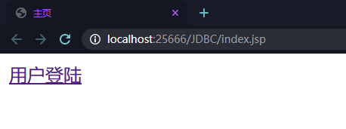
可以看到 目前还没有登陆 提示需要登陆

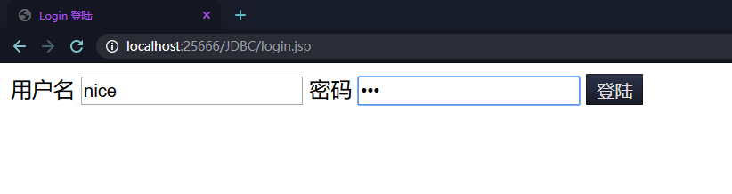
在登陆页面输入错误的管理员账号密码 点击登陆
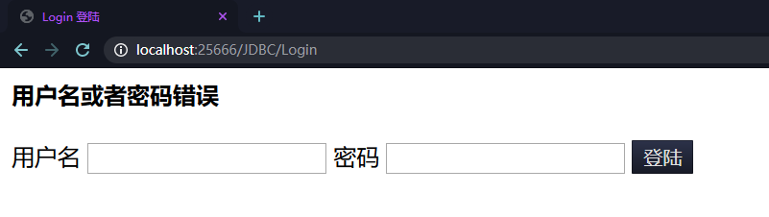
提示出错 需要输入正确的账号或者密码
输入含有敏感字符的登陆信息
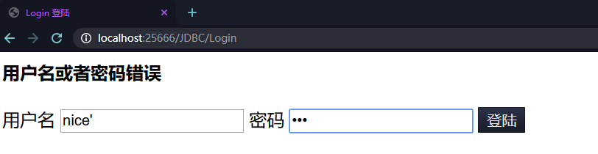
会被拦截下来
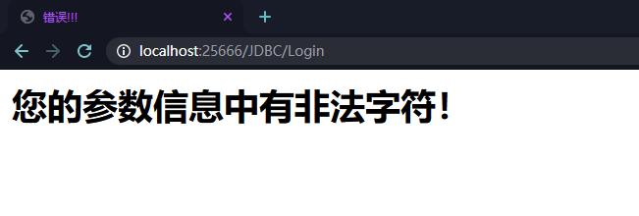
正确输入信息后
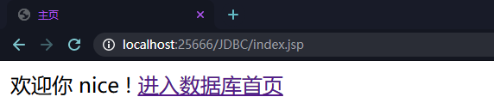
点击进入数据库首页
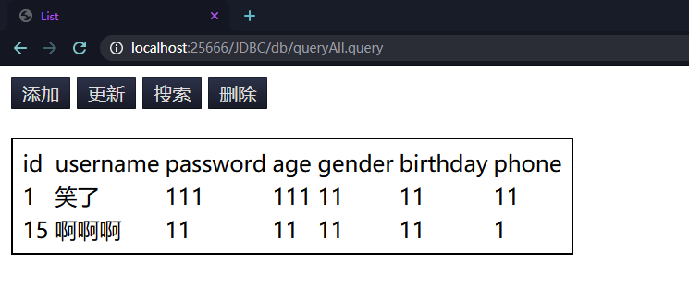
可以看到目前数据库的查询结果
与数据库内的信息一致
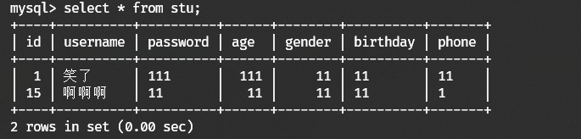
点击添加 输入信息后提交
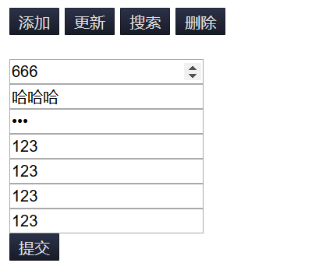
即可看到添加后的信息
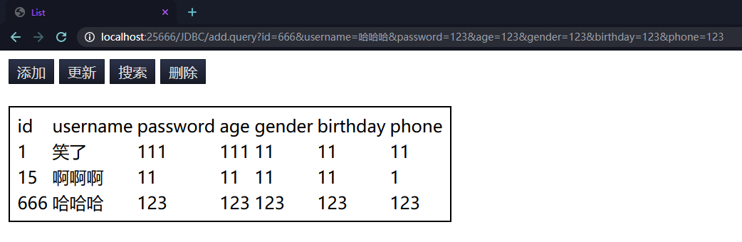
点击更新 输入信息后 点击提交
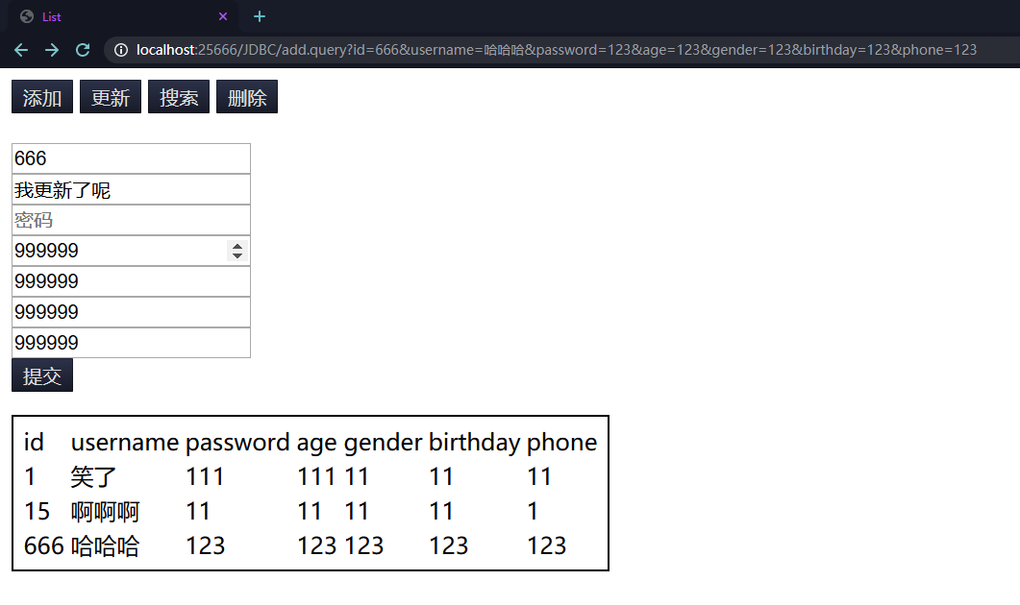
可以看到提交后的信息
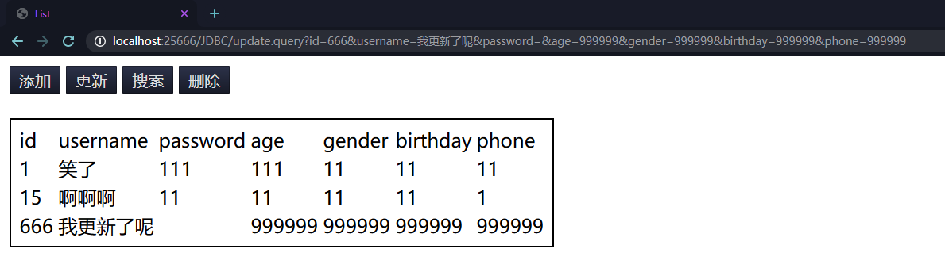
在添加和更新任意一个信息输入中 输入非法字符 如
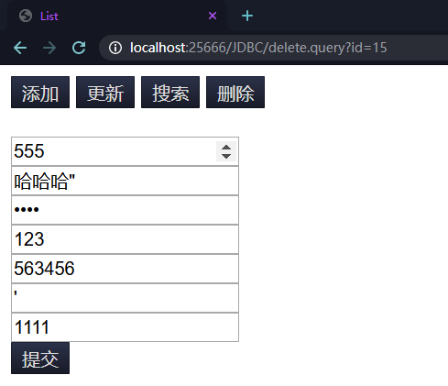
点击提交 会被拦截
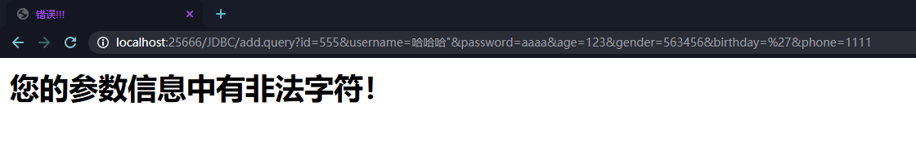

点击搜索 输入id值 提交
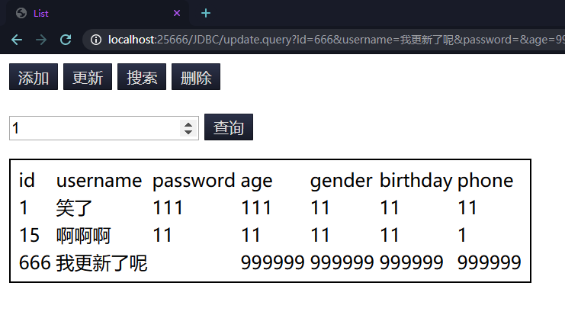
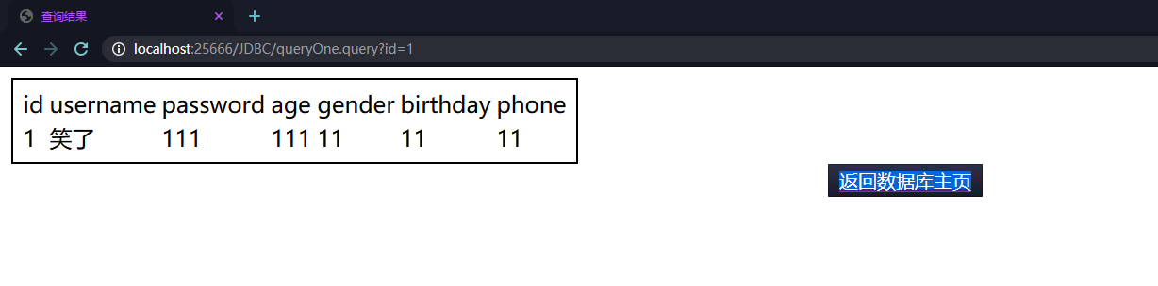

即可获得结果集 点击返回主页按钮即可返回数据库主页
点击删除 输入id 点击提交
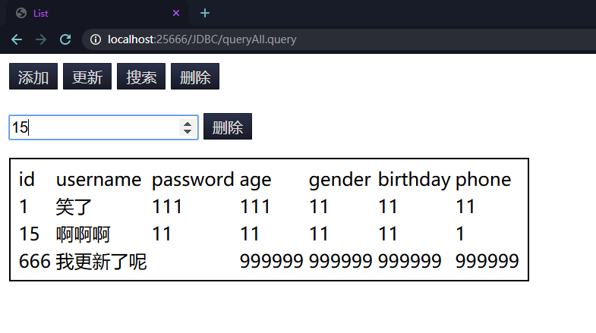
即可看到删除后的数据库情况
